****Essentials Mathematics Test #8

**60**

**Topics – Statistics & Data**

|  |  |
| --- | --- |
| **Name** | **Solution** |

* **Attempt all questions**
* **Show all working and calculations where possible**
* **Calculators are allowed**
* **One A4 page of notes is allowed**

***You must include all working out to receive full marks***

**Question 1 (10 marks)**

From the list of data displays below, choose the most appropriate way to display the data described in each part below and explain the reasons for you choice.

* Column graph
* Dot frequency diagram
* Back to back stem and leaf diagram
* Histogram

1. The heights (measured in cm) of 20 boys and 20 girls to compare them.

Back to Back Stem & Leaf Plot ✓✓

1. The eye colour of all Year 11 students.

Dot Frequency ✓✓

1. The foot length, measured in cm, of the members of your class. Histogram ✓✓
2. The percentage of students in each year at our school.

Column Graph ✓✓

1. The heights, measured in cm, of all Essentials students.

Histogram ✓✓

**Question 2 (5 marks)**

This dot plot shows the foot length of a group of students.

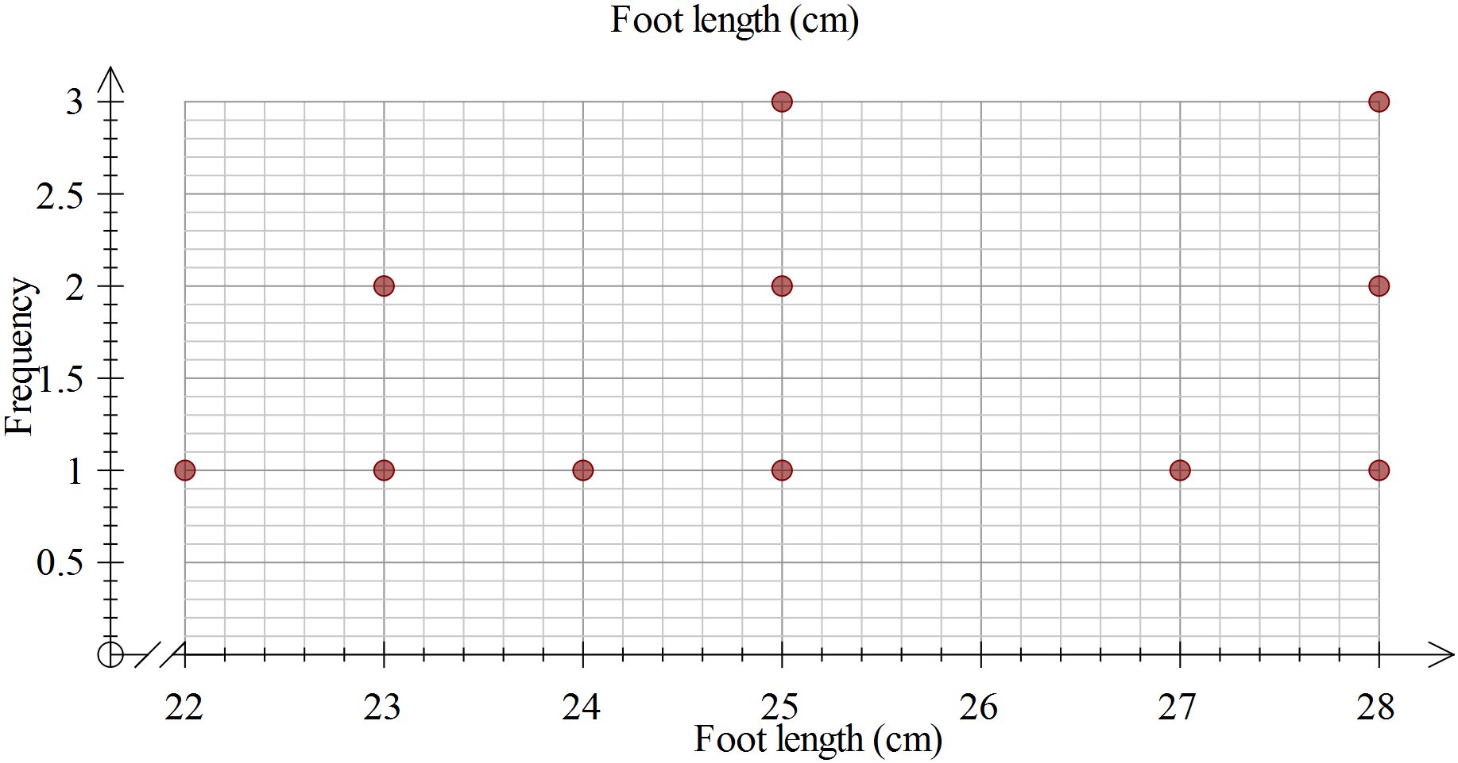

1. Calculate the range of the scores, showing your working.

Range = max-min = 28-22=6 ✓

1. Determine the mode.

Bimodal = 25, 28 ✓

1. Determine the median.

25 ✓

1. Calculate the mean, showing your working.

278/11 ✓ 25.3 ✓

1. Complete this sentence: For a student in this group, you would expect them to

have a foot length of about __25____cm. ✓

**Question 3 (3 marks)**

Two classes are marked on the same tests.

Class P has a mean of 65% and standard deviation of 5.

Class Q has a mean of 50% and standard deviation of 15.

1. Write a statement comparing the scores of the two classes, that is who had the better scores?

P- higher average scores

Q –lower average score ✓

1. Write a statement comparing the spread of the scores for the two classes.

P- most scores are close to the mean/tightly packed

Q- very spread out from the mean/spread out ✓

1. Which class would you expect to have the highest score? Explain.

Q-50 + 3 x 15 > 65 + 3 x 5 ✓

**Question 4 (20 marks – 2, 8, 6, 4)**

|  |  |
| --- | --- |
| Height (cm) | |
| Year 7 students | |
|  |  |
| Female | Male |
| 106 ✓ | 141 |
| 142 | 142 |
| 143 | 148 |
| 144 | 148 |
| 147 | 149 |
| 147 | 149 |
| 152 | 150 |
| 152 | 150 |
| 153 | 154 |
| 153 | 154 |
| 155 | 156 |
| 155 | 156 |
| 157 | 157 |
| 160 | 158 |
| 162 | 159 |
| 164 | 164 |
| 165 | 165 |
| 170 | 169 |
| 172 | 170 |
| 176 | 170 |

Consider the data to the right, showing the heights of 20 male and 20 female Year 7 students, taken from CensusAtSchool.

1. Circle or highlight any outliers in the data.

For any you find, explain why you consider it an outlier.

106 too small to be the height ✓

1. 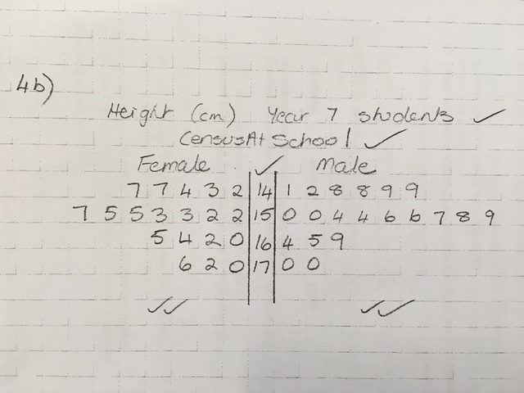Use the grid paper provided to make a back-to-back stem and leaf diagram to display this data. ✓✓✓✓✓✓✓
2. Complete the table below, showing your working, to summarize the statistics for this data.

|  |  |  |
| --- | --- | --- |
| Statistic | Female | Male |
| Mode | No Mode ✓ | No Mode ✓ |
| Median | 155 ✓ | 155 ✓ |
| Range | 176-142 = 34 ✓ | 170 – 141 = 29 ✓ |

1. Using your stem and leaf plot and/or the table in c), compare the data for males and females.

In what ways are the two groups similar?

Median same ✓

Symmetrical stem and leaf ✓

In what ways are the two groups different?

Male lower range ✓

Female highest value ✓

**Question 5 (22 marks-2, 10 ,4 , 6)**

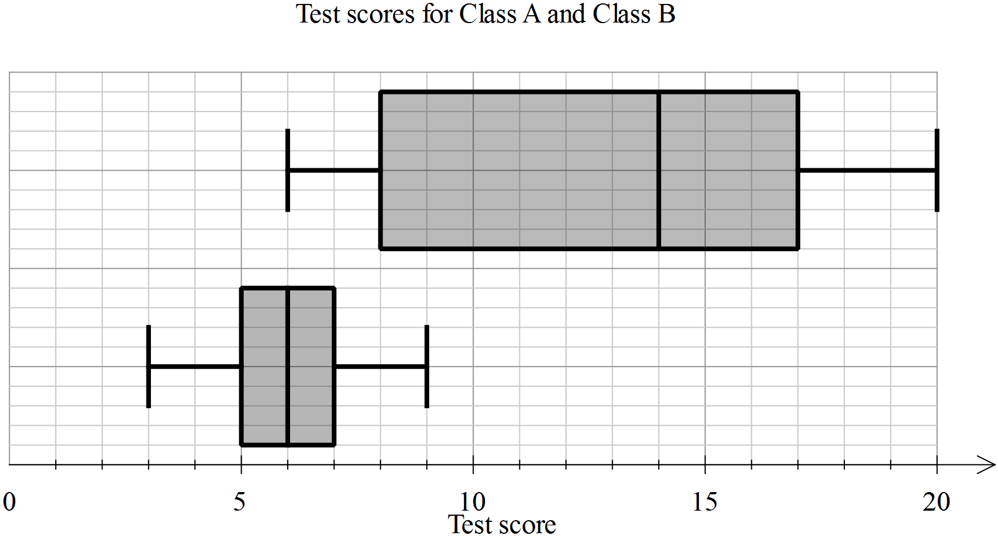

✓

A

B

1. Eric is in Class A, he scored 5 on the test. Label the two box plots with their class names.
2. Use the table below to enter the appropriate values for each of the plots.

|  |  |  |
| --- | --- | --- |
| Statistic | Class A | Class B |
| Minimum | 3 | 6 |
| First quartile | 5 | 8 |
| Median | 6 ✓✓ | 14 ✓✓✓ |
| Third quartile | 7 | 17 |
| Maximum | 9 | 20 |

Calculate the range and interquartile range for each class, showing the working, in the table below.

|  |  |  |
| --- | --- | --- |
| Statistic | Class A | Class B |
| Range | Max-min 9-3=6 ✓ | Max-min 20-6=14 ✓ |
| Interquartile range | 3rd – 1st = 7-5 = 2 ✓ | 3rd – 1st = 17-8 = 9 ✓ |

1. In each of the statements below, write A and B as appropriate to make the statement true.

* Class _B__ has a much greater range than Class _A__
* The minimum for Class _B__ is the same as the median for Class __A_
* For Class _B__, the second and third quartiles are the same width, whereas for Class __A_, the second quartile is much greater than the third quartile.

END OF TEST